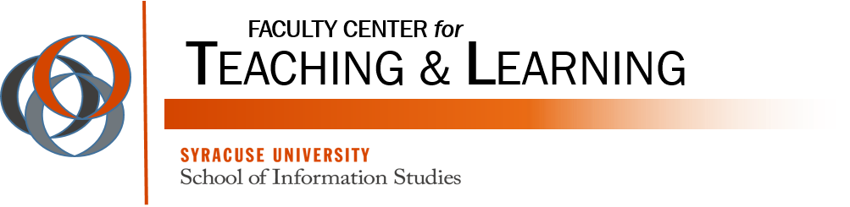

All About Video

Table of Contents
Blackboard 9.1: Adding YouTube Videos 3
Introduction 4
Video and Audio Formats 4
Why MPEG 4 and MPEG 3? 4
About MPEG 3 4
About MPEG 4 5
Welcome Video Script Example 5
Why Use Video Communication? 6
Synchronous Video 7
Asynchronous Video 8
Tips To Looking Good on Video 9
Creating Interaction 10
Modifying Videos 12
Video Editing 12
Subtitles/Transcription 13
Merging YouTube Videos Together 13
Storing Videos 14

Blackboard 9.1: Adding YouTube Videos

YouTube clips are easily added to your Blackboard course. When you embed a video in Blackboard, it allows students to view the video from the course -- instead of navigating away from the course to YouTube website.

YouTube Mashup:
- Navigate to the content area where you would like to add a YouTube video.

- Click the Build Content button to open the drop down menu. Then, choose YouTube Video under the Mashups category.

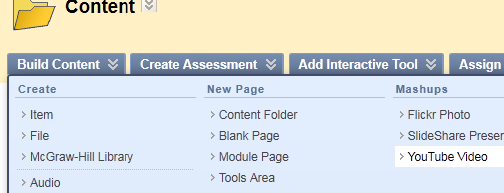

- Enter a search term in the box and then click Go.

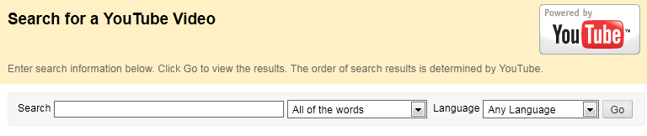

- You will be able to browse the YouTube results from within Blackboard. Once you find your clip, click the Select button located underneath the video’s thumbnail preview.

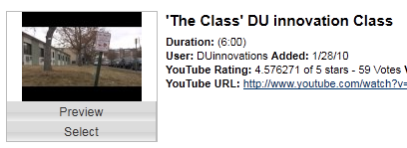

- Next, add a description of the video (optional) and choose the video display options.

- Click Submit to finish. Your video will display directly within the content area.

Embed from YouTube: (this is an alternative to the mashup process to add a video to your course)

- Locate the Video clip from www.youtube.com

- Click on the Share button, then Embed, and Highlight and Copy the HTML code.

- From your Blackboard course menu, click on the Content Area where you wish to add your new file and click on the Build Content drop-down menu.

- Choose to Create Item and give your video a name.

- Click on the <> (html) icon on the visual Textbox Editor toolbar.

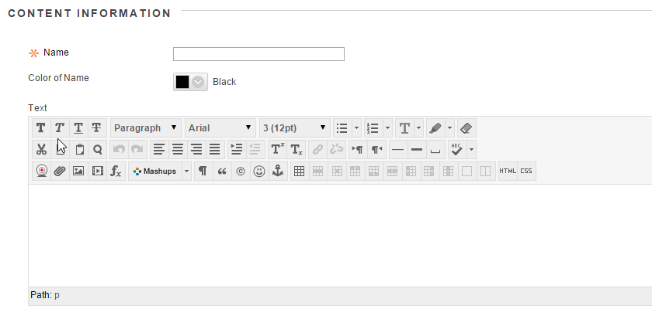

- The HTML View Window will open.
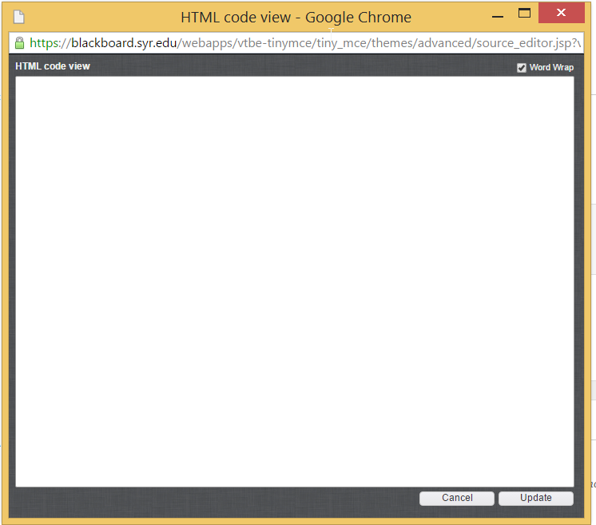

- Paste the html text into the Visual textbox editor.

- Click Submit.

Introduction

Digital media is a powerful tool that can enhance your online course. Recent developments and market trends have changed the rules and media formats that need to be considered when creating media for your course. Choosing the correct video and audio format is the first step to ensuring a successful experience for both instructor and student. Podcasts, a form of digital media meant for downloading to a portable media device is included in this discussion.

Video and Audio Formats
Popular media formats for audio and video include .AVI (Audio Video Interleaved - Microsoft), .MOV (Apple – Quicktime), .WMV (Windows Media®), MPEG 3, and MPEG 4. Each requires software that will encode video/audio to that format, and also a player that will decode the video/audio for playback. All these formats are currently being used in online courses with great success. The latest market trends are now suggesting that MPEG 4 for video and audio and MPEG 3 for audio only are “the” standards for digital media.

Why MPEG 4 and MPEG 3?
MPEG 4 and MPEG 3 are the standard because of consumer response. Apple adopted MPEG 4 early on as the video format for playback on their iPods® that support video. Apple and YouTube worked together to allow YouTube video to be accessed by an Apple TV®, iPhones®, and the iPod® Touch. YouTube moved from Flash Video to MPEG 4 to accommodate these devices, and Adobe soon followed by updating its Flash Player to play MPEG 4 video and audio. The new High Definition Blu-ray™ DVD standard uses MPEG 4, as does DirecTV® and Dish Network® for the delivery of HD programming on their satellite networks.
MPEG 3 has become the standard for compressed digital audio files. It was made popular by consumers wanting to compress large amounts of audio onto a single CD. It is the standard for small portable digital media players (often called MP3 players) on the market today.
Thank the students in your classes for buying millions of iPods that helped set this standard. Your students are already familiar with MPEG 4 and MPEG 3 and are using these standards.

About MPEG 3
MPEG 3 (denoted by an .MP3 file extension) is a standard for audio only files. Every consumer portable media player supports this format. If you are creating audio files for your online course, create them in the MP3 format. Audacity® is a free audio editing tool available for both the PC and Mac that can be used to create MP3 files.

About MPEG 4
MPEG 4 (denoted by .MP4, .M4V, .M4A, or .M4B file extension) is a format for audio only, video only, or video with audio, and some enhanced versions that are audio with graphics. Sometimes MPEG 4 video is called H.264, in reference to the compression standard that is used to create the MPEG 4. Many programs like Final Cut®, iMovie®, Vegas® Movie Studio, Vegas® Pro, QuickTime® Pro, and GarageBand®, are examples of programs that can be used to capture, edit, and compress media into the MPEG 4 format.

Welcome Video Script Example

Since the goal of the video is to welcome the students to the course and create a good first impression, it is recommended that you craft the content carefully. As with any video, lighting and audio/video quality are important, but here it is equally imperative that you come across as warm, approachable and genuine. Without too much work, you can make it generic enough that the same video can be used to accompany each course you teach. This can be accomplished by saying “welcome to the course” as opposed to “welcome to principles of marketing,” for example, and giving the year you started teaching at the institution as opposed to the number of years it has been.
The following is a sample script to use as a building block. Be sure to add to it information relevant to you and the courses you teach:
Hi, I’m Dr. (so and so) and I wanted to take this opportunity to welcome you to this course.
I have been teaching at (whichever) University since (a year), and I always look forward to the beginning of a new semester. Regardless of how well you have or have not done in previous semesters, it seems like every new one — and the new courses that go with it — provide for a fresh start. As great as that is, sometimes it can also be a little intimidating: You have to learn a new topic from a new instructor in a new format and so on. I want you to know that you are not alone in this journey. I am here and I’m available to help.
My contact information is in the syllabus as well as at the top of the course information in Blackboard. You’ll find that one of the best things you can do when you have a problem is seek help. If you were in a traditional classroom, you’d undoubtedly raise your hand if you had a problem and you should do the same here.
Lastly, I know that there are a lot of choices today when it comes to education. Those choices include different schools, different courses, and even different instructors. Your choices led you here and I want to thank you for that. Working together, we can have a great semester. I know I am looking forward to it, and I hope you are, too.

Why Use Video Communication?

- Overcome isolation

- Build rapport

- Develop speaking skills

- Develop visual communication skills

- Develop digital literacy

SYNCHRONOUS |  | ASYNCHRONOUS
Spontaneous |  | Thinking Time
No Reflection |  | Reflection
Single Viewing |  | Multiple Viewings
Turn Taking |  | Maximum Particpation
Time Economical |  | Time Demanding
Once Only |  | Re-Useable

ASYNCHRONOUS
Thinking Time
Reflection
Multiple Viewings
Maximum Participation
Time Demanding
Re-Useable

Synchronous Video

Adobe Connect – webconferencing platform that allows for both synchronous and asynchronous (recording option) communication with students.
http://webconference.syr.edu

Appear.in – video conversations with up to 8 people for free. No login required – no installs

https://appear.in

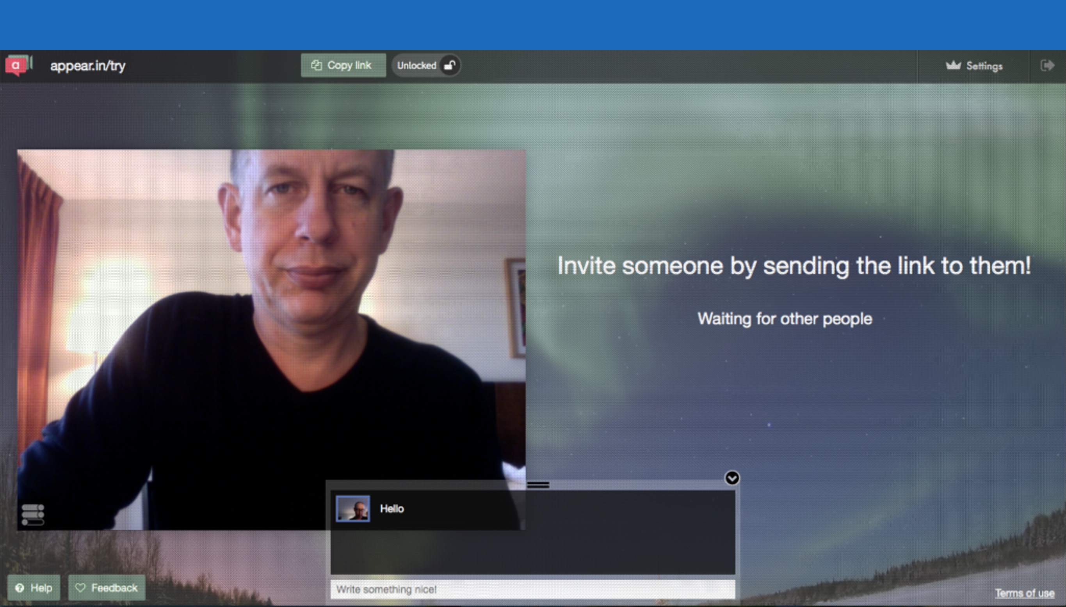

Asynchronous Video

mailvu – enables the ability to create videos and send them via email.

http://mailvu.com

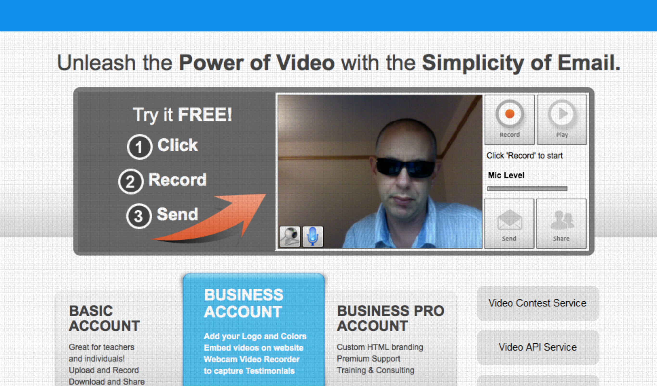

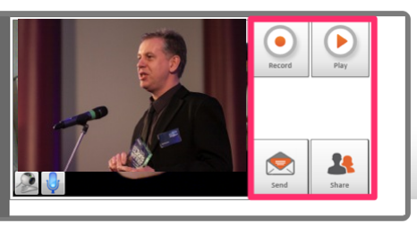
Send the email in the browser or on your phone

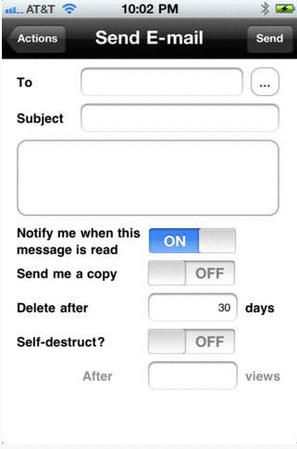

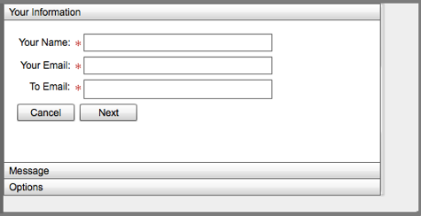

Tips To Looking Good on Video

- Smile
- Don’t Read
- Eye Contact
- Clothes
- Posture
- Lighting

If all else fails…

Fotofriend – create videos using a variety of different layouts and formats

http://www.fotofriend.com/videobooth

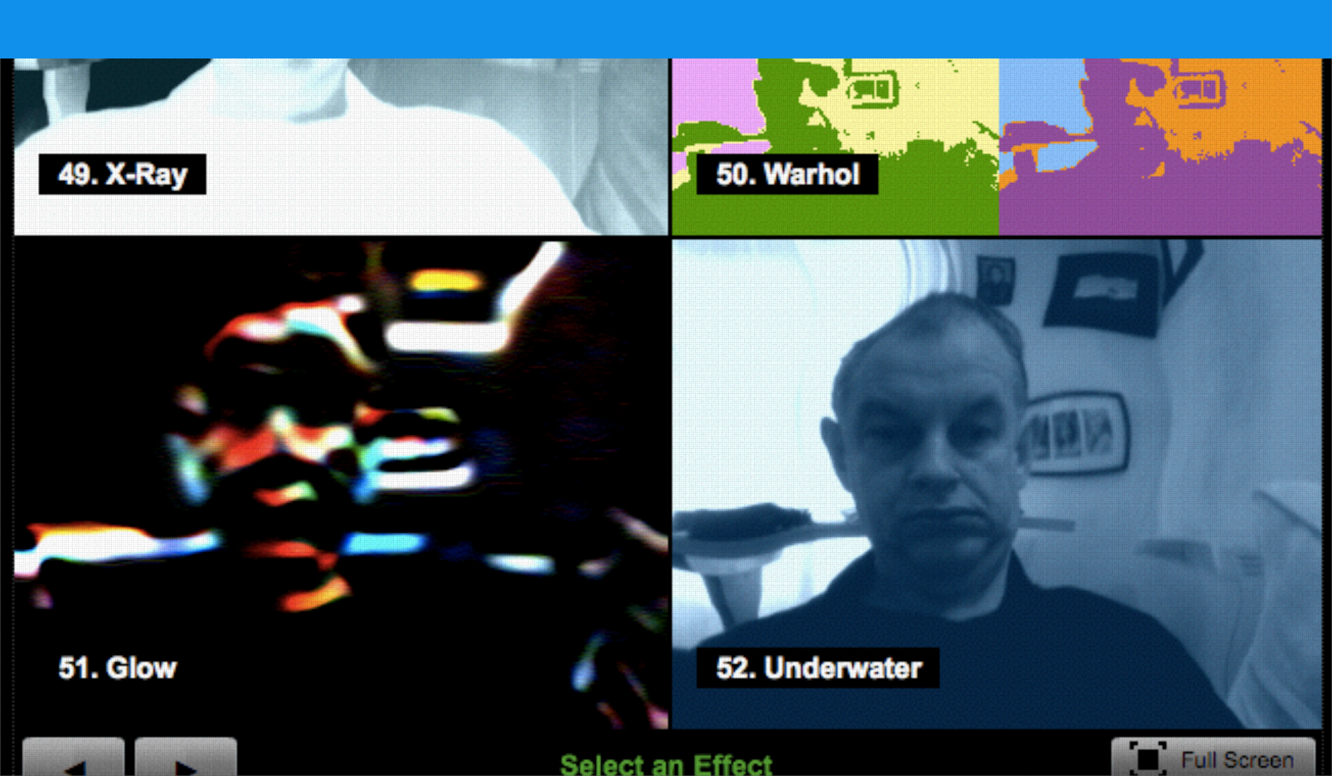

Creating Interaction

Vialogues – asynchronous video discussion tool which can be used for leveraging digital videos for learning by adding group interaction as part of the viewing experience.

https://vialogues.com

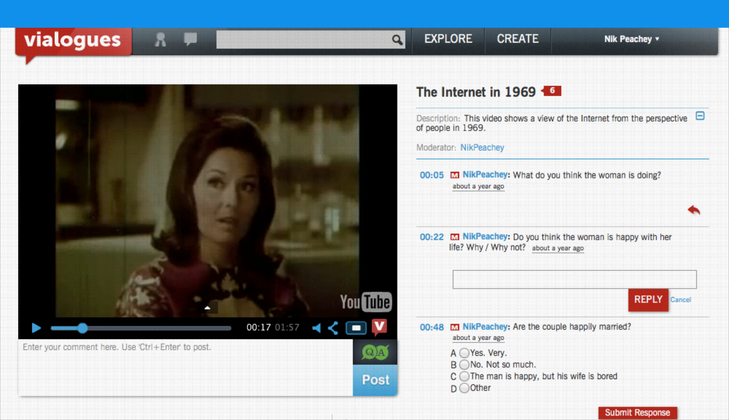

VideoNot.es – the easiest way to take synchronized notes. Allows for the clicking on a line of a note and the video jumps to the relevant part.

http://www.videonot.es

EDpuzzle – one of the easiest ways to engage your students with videos. Pick a video and ask questions that students can answer while viewing.

http://edpuzzle.com

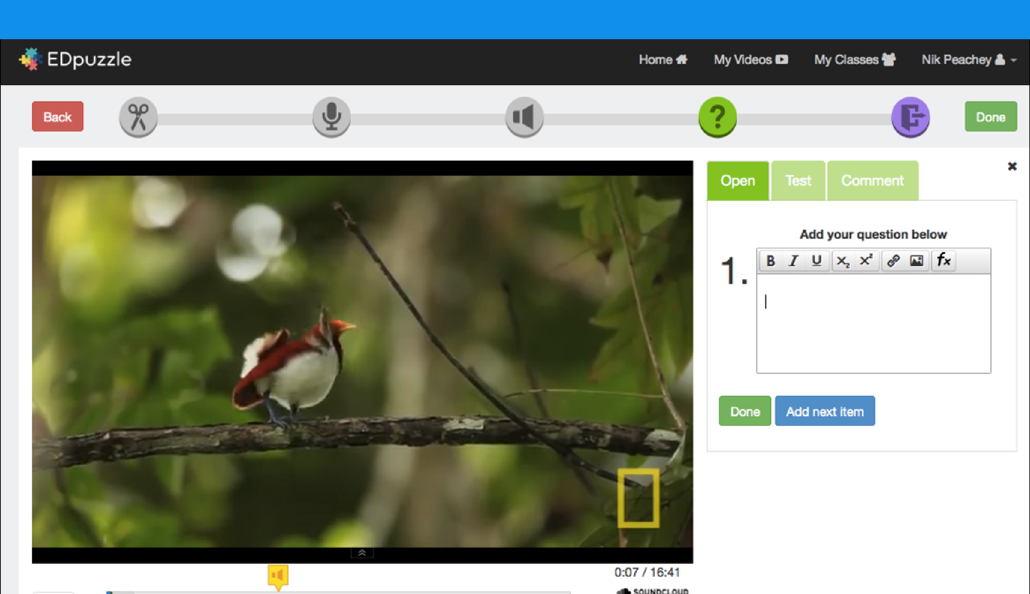

Modifying Videos

Removing Ads

quietube – watching web videos without advertising, comments, etc. A stripped down viewing experience with very little viewing distractions.

http://www.quietube.com

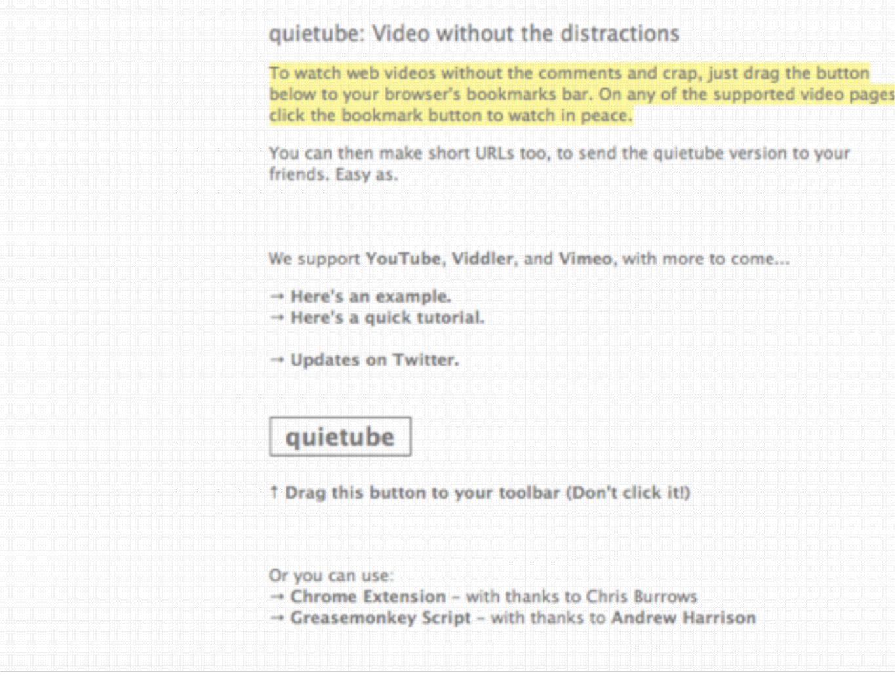

Video Editing

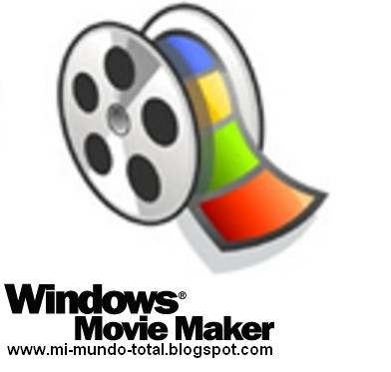
- Microsoft – Windows Movie Maker

- Apple - iMovie

Subtitles/Transcription

YouTube

http://www.youtube.com

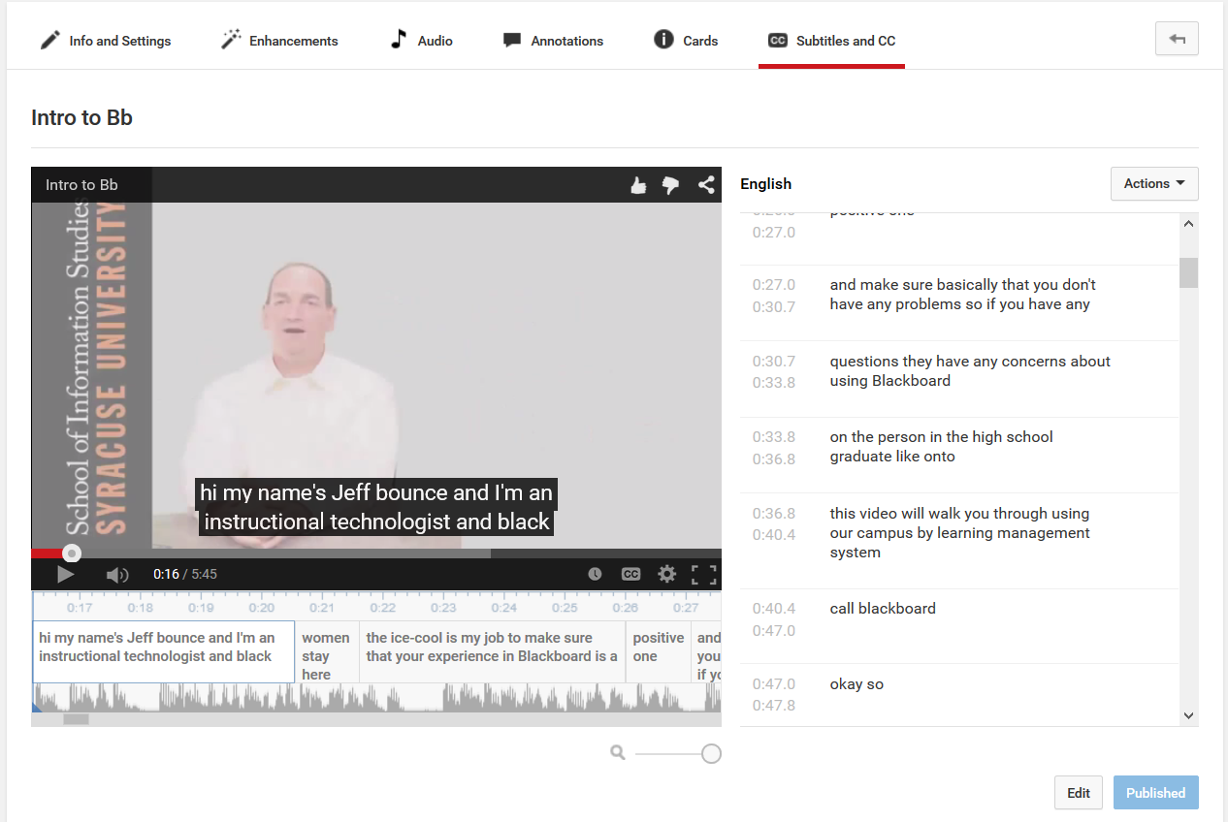

Merging YouTube Videos Together

DRAGONTAPE – a collaborative online video merging service with which you can drag online videos starting with YouTube onto a “tape” that can be shared with the world.

http://www.dragontape.com

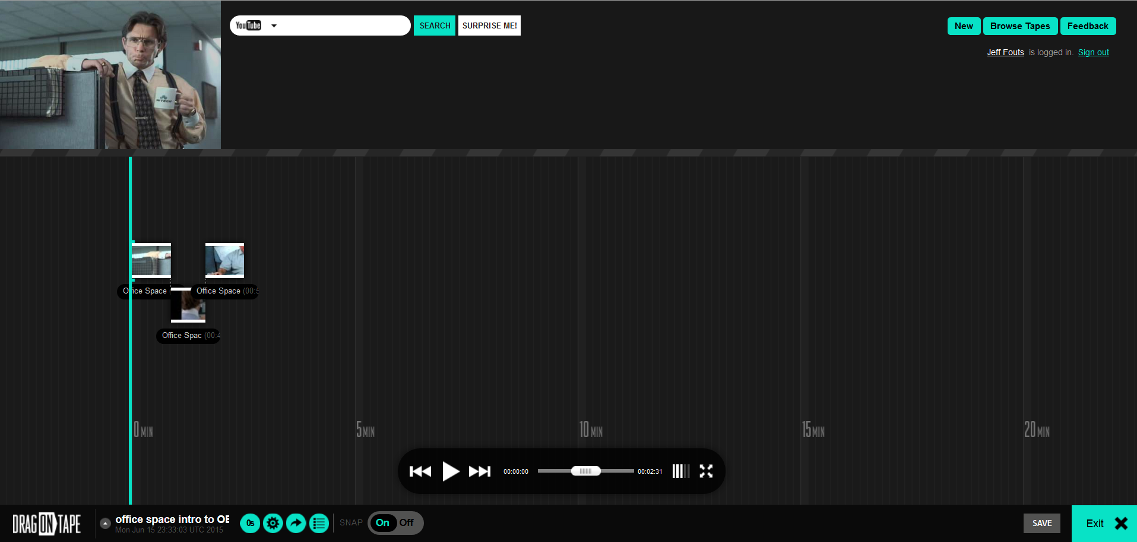

Storing Videos

Ensemble Video - Ensemble Video is a powerful online video platform for Syracuse University. Use Ensemble Video to enhance teaching, learning and communication across your courses. You can also use Ensemble Video to excite your visitors, recruit students and promote your brand while managing all your media in an easy to use video content management system.
http://ensemble.syr.edu

